- Brief Description:

  - Similar to 1997 game, Snake.
  - User controls satellite
  - Satellite ‘collects’ disasters such as illegal mining and fires
  - When a disaster is collected, the satellite gets an additional star in it’s star dust trail
  - The user has to avoid comets. If they hit them or their trail, it’s game over
  - Game side scrolls along

- Neural Network Involvement:

  - Neural Network helps user:
    - Use real data satellite images
    - Neural network identifies emergency
    - Creates cartoon image which the user collects

  - Neural Network competes against user
    - Neural Network ids emergence
    - Pre-written script move Neural Network towards emergency, avoid comets etc

- Difficulty level:
  - Four difficulties
    - Easy
    - Medium
    - Hard
    - Real
      - The speed will increase as difficulty increases
  - More comets with each difficulty
  - Neural Network competes against user
    - Delay in network identifying object(longer delay for easier difficulty
    - Random mode every set interval(large intervals for harder difficulty)

- Controls:
  - Joy stick will control the direction in which the satellite moves
  - Button press will allow the snake to eat the object it is moving towards

- Scoring
  - When the satellite sees an object it gains one point

- End Game
  - The game will end when one of the snakes bashes into another oor itself.

- Resources:
  - We will use a basic template for snake.
  - There will be a cratoon background
  - there will be cartoon objects on top of this background

- Potential Issues
  - Processing power of Raspberry Pi may be limited
  - The NN might not be able to run in real time

- Education value:
  - Neural Network helps user:
    - Instructions at start will explain Neural Network will identify emergencies
    - User will see cartoon object appear, perhaps with text saying Neural Network has identified another emergency
  - Neural Network helps user:
    - Stat at end showing how many emergencies the neural network identified for you
  - Neural Network competes against user
    - Ghost overlay will show neural network moving towards objects
    - Score at end shows what neural network got

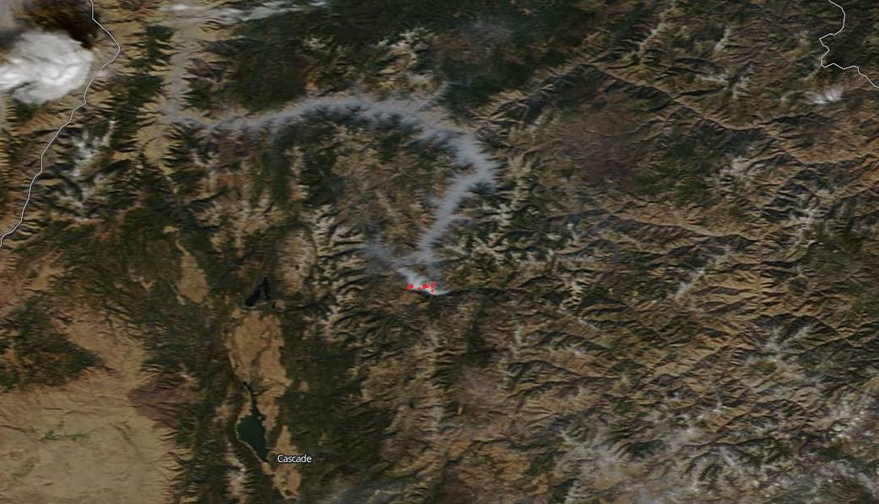
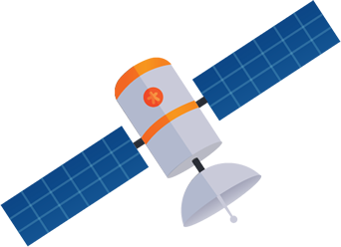



image sources:

- Comet (https://pngtree.com/freepng/vector-flame-comet_2080782.html)
- Satellite(https://pngtree.com/freepng/cartoon-satellite_154692.html)
- Trail(http://clipart-library.com/images/6irpKnBiK.png)
- Background(https://www.nasa.gov/sites/default/files/thumbnails/image/image-download_3.jpg)
- Fire (http://images.clipartpanda.com/fire-clip-art-red_yellow_fire_logo.png)#

